1.
1

2.
(i) 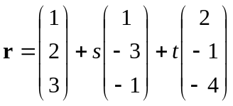
(ii) 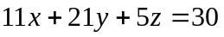

3.
(i) Prove by mathematical induction.
(ii) Prove by mathematical induction.

4.
(i) (a)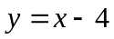 , 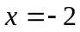
(i) (b) local minimum point : 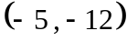 , local maximum point : 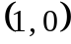
(ii)

5.
(i) 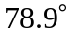
(ii) 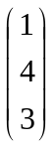
(iii) 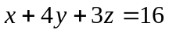
(iv) 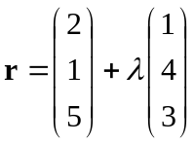
(v) 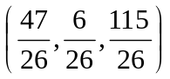
(vi) 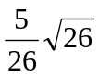

6.
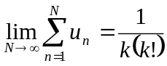

7.
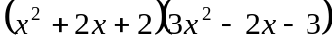

8.
